Wandering in the Woods: An Educational Simulation Game
Agile Project Documentation
Software Engineering A Practitioner’s Approach 9th Edition Supplement

Table of Contents
1.0 Introduction 2
1.1 Purpose 2
1.2 Wandering in the Woods: An Educational Simulation Game 2
2.0 Process Model 3
3.0 Use Cases 4
3.1 Use Case 1: Select Grade Level 5
3.2 Use Case 2: Configure Grid Settings 5
3.3 Use Case 3: Place Explorers 5
3.4 Use Case 4: Run Simulation 6
3.5 Use Case 5: Form Groups 6
3.6 Use case 6: Select Movement Protocol 6
3.7 Use case 7: Run Research Trials 7
3.8 Use case 8: View Results 7
4.0 UML Model 8
4.1 Use Case Diagram 8
4.2 Class Diagram 9
4.3 State Diagram 10
4.4 Activity Diagram 11
5.0 Customer Journey Map 13
6.0 Personas 14
7.0 UI Mock-up 15
8.0 Testing Strategy 17
8.1 Unit Testing 18
8.2 Integration Testing. 18
8.3 Usability Testing 19
8.4 Validation Testing 19

Introduction

Purpose
The documentation follows an agile philosophy, emphasizing minimal but sufficient detail to ensure that the development team, instructors, and stakeholders share a clear understanding of the system’s requirements, architecture, and behavior. Consistent with agile principles described in SEPA, this document includes only information that the development team determined necessary to preserve and maintain during the project lifecycle.
This document is considered a living artifact that represents the current iteration of the system design. As the project evolves through prototyping, testing, and refinement, this documentation may be updated to reflect new insights, refinements, or additional functionality. Feedback and critique are encouraged to improve both the system and its supporting models.
This case study is intended to support instructors and students seeking a concrete, multi-level example of applying software engineering principles to an educational simulation. In particular, it demonstrates how a single software system can support progressively complex functionality across multiple user groups while maintaining a shared architectural foundation.

Wandering in the Woods: An Educational Simulation Game
Wandering in the Woods is a desktop-based educational simulation game designed to support the development of computational thinking, problem-solving, and scientific reasoning skills across multiple grade levels. The system is implemented as an interactive graphical application and is intended for offline use in classroom or individual learning environments.
The game presents users with a grid-based “forest” environment in which one or more autonomous explorers move according to defined movement rules or protocols. The system supports three distinct learning tiers, each aligned with a different grade range:
- Kindergarten–Grade 2 (K–2):
A simplified simulation where two characters move randomly within a fixed 5×5 grid. This mode emphasizes observation, counting, pattern recognition, and patience.
- Grades 3–5:
A more advanced exploration mode that introduces configurable grid sizes, multiple explorers, different starting strategies, and group formation mechanics. This level encourages strategic thinking, collaboration, and basic data analysis.
- Grades 6–8:
An expanded research-oriented mode that incorporates selectable movement protocols, experimental trials, automated data collection, and statistical analysis. This level supports hypothesis testing and application of the scientific method.
Users interact with the system through a graphical user interface using mouse and keyboard input. Core system functionality includes grid configuration, player placement, movement simulation, protocol selection, data collection, and visualization of outcomes. Across all grade levels, the system maintains a consistent conceptual model while scaling complexity to match the learner’s cognitive and analytical abilities.
The initial set of system capabilities was intentionally limited to reduce development risk and ensure stability across grade levels. Future enhancements may include additional movement protocols, richer data visualization tools, expanded analytics, and extended configuration options. These enhancements will be considered after successful validation of the current prototype.

Process Model
The development of Wandering in the Woods: An Educational Simulation Game follows an evolutionary software process model grounded in agile development principles. This model was selected to support incremental delivery, continuous feedback, and risk reduction while developing a system intended for multiple user groups with increasing levels of complexity.
The evolutionary model combines key characteristics of both agile and spiral process models as described in SEPA. Rather than attempting to define and implement all system features upfront, the project was developed through a sequence of iterative prototypes. Each iteration focused on delivering a stable, functional subset of the system that could be evaluated and refined before additional complexity was introduced.
The project naturally lent itself to this approach due to its tiered educational structure. Development began with the K–2 grade level simulation, which provided a minimal, controlled environment with fixed grid dimensions, limited actors, and simple random movement. This initial prototype allowed the development team to validate core mechanics such as grid rendering, movement logic, timing, and user interaction.
Subsequent iterations expanded upon this foundation by introducing:
- Configurable grid dimensions and multiple explorers (Grades 3–5)
- Group formation mechanics and shared movement behavior
- Movement protocols, experimental trials, and data analysis tools (Grades 6–8)
Each iteration incorporated feedback from testing and informal user evaluation to guide design decisions. Risk was managed by limiting new functionality introduced in any single iteration and by ensuring that existing features remained stable through regression testing.
The evolutionary process model also supported parallel refinement of system components. While gameplay mechanics evolved, user interface elements, control schemes, and data collection features were iteratively improved to maintain usability across all grade levels. This approach ensured that the system remained coherent and accessible despite increasing internal complexity.
Overall, the evolutionary process model enabled the development team to balance educational goals, technical constraints, and usability requirements while delivering a robust and extensible educational simulation

Use Cases

The following use cases were defined by the development team as the core functional requirements for the initial working prototype of Wandering in the Woods: An Educational Simulation Game. These use cases represent the minimum feature set required to support meaningful interaction across all supported grade levels.
The baseline functionality defined here can be extended through the addition of new use cases as the project evolves. Each use case includes the name, primary actor, preconditions, description, and acceptance criteria. The use cases are intentionally scoped to reduce development risk while supporting iterative expansion through the evolutionary process model.

Use Case 1: Select Grade Level

Primary Actor:
Student / User
Preconditions:
The application has been launched successfully and the main menu is displayed.
Description:
As a user, I want to select a grade-level mode (K–2, Grades 3–5, or Grades 6–8) so that the game presents content and mechanics appropriate to my learning level.
Acceptance Criteria:
I can select one of the available grade-level options from the main menu.
The system loads the corresponding game mode with the correct features enabled.

Use Case 2: Configure Grid Settings
Primary Actor:
Student / User
Preconditions:
A grade level requiring configuration (Grades 3–5 or Grades 6–8) has been selected.
Description:
As a user, I want to configure the grid dimensions and number of explorers so that I can control the complexity of the simulation environment.
Acceptance Criteria:
- I can increase or decrease grid width and height within allowed limits.
- I can select the number of explorers to include in the simulation.
- The selected configuration is reflected when the simulation begins.

Use Case 3: Place Explorers
Primary Actor:
Student / User
Preconditions:
A grid has been configured and the game is in the setup phase.
Description:
As a user, I want to place explorers on the grid using a selected placement strategy (corner, random, or manual) so that I can test different starting conditions.
Acceptance Criteria:
- I can choose a placement strategy.
- Explorers appear on valid grid locations.
- Manual placement allows me to select specific grid squares.

Use Case 4: Run Simulation
Primary Actor:
Student / User
Preconditions:
Grid configuration and explorer placement are complete.
Description:
As a user, I want to start the simulation so that the explorers move within the grid according to the game rules or selected movement protocol.
Acceptance Criteria:
- The simulation begins when I start the game.
- Explorers move simultaneously according to the defined rules.
- The system updates explorer positions and visited squares correctly.

Use Case 5: Form Groups

Primary Actor:
System (initiated by explorer movement)
Preconditions:
Multiple explorers are active in the simulation.
Description:
As the system, I want to detect when explorers occupy the same grid square so that they can form a group and move together.
Acceptance Criteria:
- Explorers that meet in the same square form a group.
- Grouped explorers move as a single unit.
- The system tracks group membership correctly.

Use case 6: Select Movement Protocol
Acceptance Criteria: I can make changes to the objects in my room.
Primary Actor:
Student / User
Preconditions:
Grades 6–8 mode is active or an interactive protocol-enabled mode is selected.
Description:
As a user, I want to select or change the movement protocol so that I can observe and compare different search strategies.
Acceptance Criteria:
- I can select from available movement protocols (e.g., random, systematic, biased, spiral).
- The selected protocol determines explorer movement behavior.
- Protocol changes take effect during gameplay when allowed.

Use case 7: Run Research Trials
Primary Actor:
Student / User
Preconditions:
Grades 6–8 research mode is selected and experimental parameters are configured.
Description:
As a user, I want to run multiple automated trials so that I can collect data on simulation performance.
Acceptance Criteria:
- I can specify the number of trials to execute.
- Trials run automatically without user intervention.
- The system records move counts and completion data.

Use case 8: View Results
Primary Actor: Student / User
Preconditions: One or more simulations or trials have completed.
Description: As a user, I want to view the results of the simulation so that I can analyze performance and compare outcomes.
Acceptance Criteria:
- I can view move counts and summary statistics.
- Results correspond to the selected grid and protocol settings.

UML Model
The Unified Modeling Language (UML) models presented in this section describe the static structure and dynamic behavior of the Wandering in the Woods system. These models are derived directly from the implemented Python codebase and reflect the system’s architecture, control flow, and user interaction patterns.
The UML artifacts are intentionally lightweight and align with the agile documentation philosophy described in SEPA. They are intended to support understanding, communication, and future extension of the system rather than exhaustive specification.

Use Case Diagram

The use case diagram represents the interaction between the user and the Wandering in the Woods system. The primary actor is the Student/User, who interacts with the system through menu selection, configuration options, and gameplay controls.
At a high level, the user is able to:
- Select a grade level
- Configure the simulation environment
- Place explorers
- Run the simulation
- Run research trials
- View results
Several use cases extend others. For example, configuring grid settings and selecting movement protocols extend the core simulation functionality.
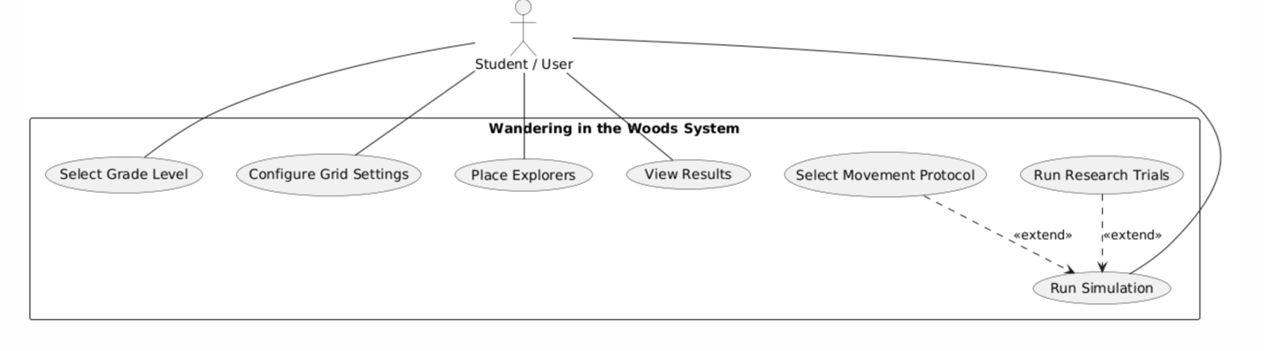

Class Diagram

The class diagram models the core software structure of the system. The design is modular and separates concerns between:
- Application control and execution
- Game logic and simulation state
- Grade-level–specific behavior
- Configuration constants
The diagram below is derived from the following files:
- main.py
- game_engine.py
- k2_game.py
- grades35_game.py
- grades68_game.py
- constants.py
Key Design Concepts
- A central GameEngine controls simulation state and progression.
- Grade-specific classes encapsulate differences in rules and behavior.
- Explorer entities maintain position and movement logic.
- Constants are isolated to support easy tuning and reuse.
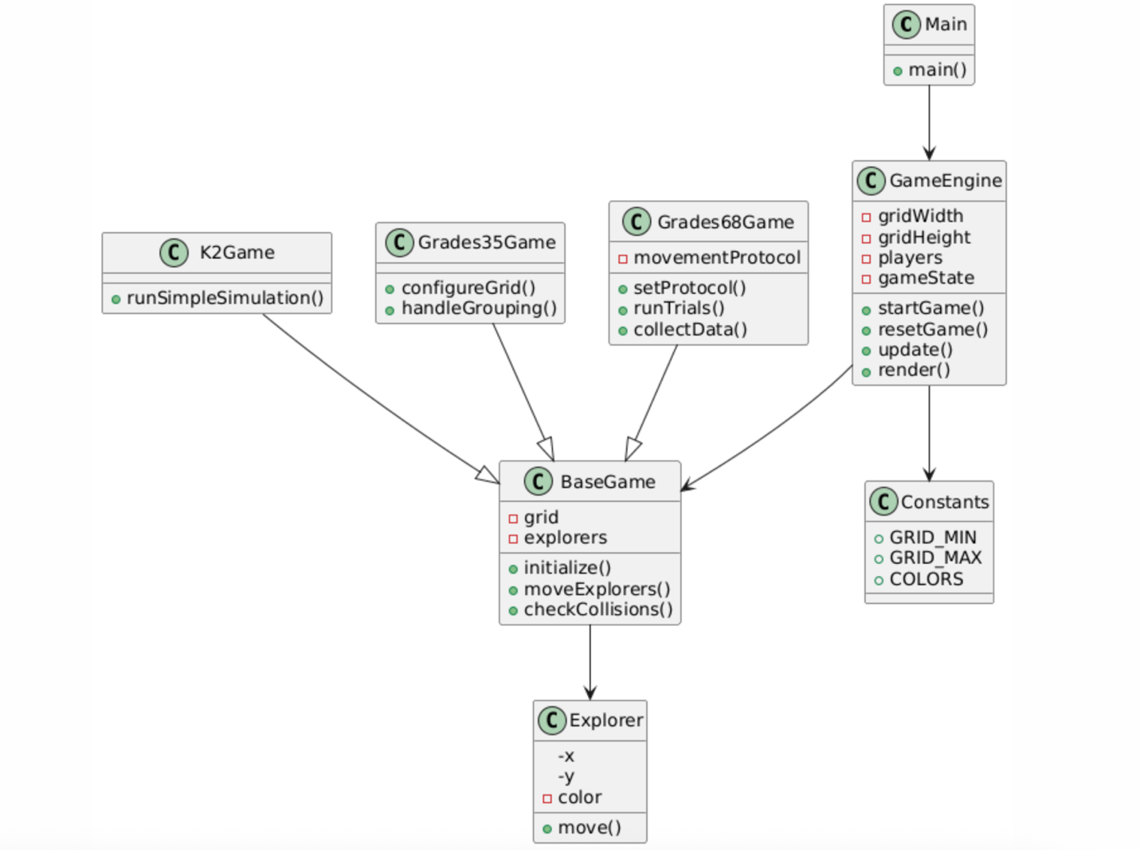

State Diagram
The state diagram illustrates the high-level operational states of the system during normal execution.
The system begins in a Main Menu State, where the user selects a grade level. From there, the system transitions into a Setup State, where configuration and placement occur. Once setup is complete, the system enters the Simulation Running State, during which explorers move and interactions are processed.
The user may pause, reset, or return to the main menu at any time. Upon completion or exit, the system transitions to a Terminate State.
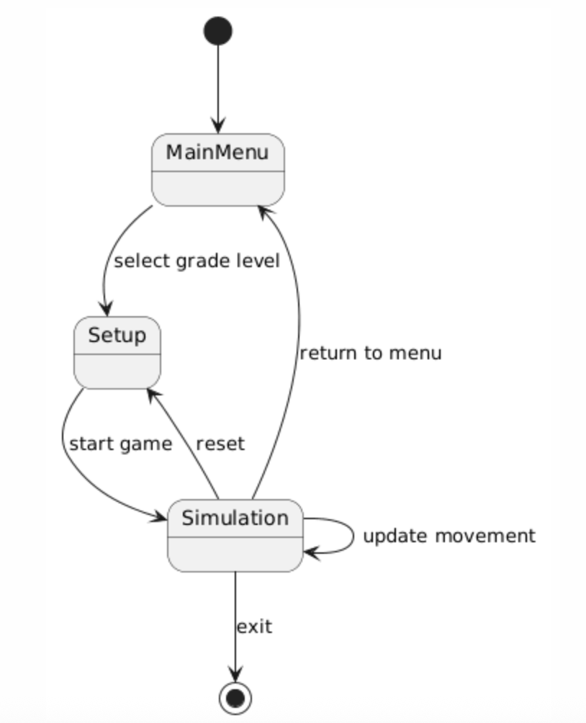

Activity Diagram

The activity diagram provides a detailed workflow view of system behavior, emphasizing control flow and concurrency.
After launching the application, the user selects a grade level and configures the game environment. The system then initializes the grid and explorers. During simulation, explorer movement and collision/group detection occur repeatedly until a termination condition is met. In Grades 6–8 research mode, the activity loop may execute repeatedly for multiple trials while collecting data.
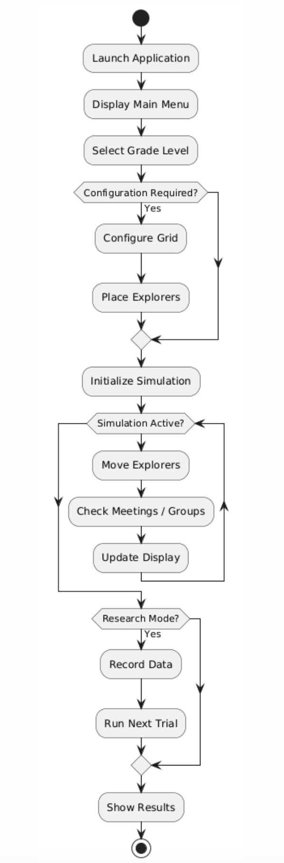

Customer Journey Map

A customer journey map was developed for Wandering in the Woods: An Educational Simulation Game to better understand the end-to-end experience of users interacting with the system. The journey map captures the user’s goals, actions, and decision points as they progress through the application, from initial launch to completion of a simulation or research activity.
The primary goal of the user is to explore search strategies and movement behavior within a grid-based environment in a way that is appropriate to their educational level. The journey varies slightly depending on grade level, but all users follow the same general progression through the system.
The typical user journey consists of the following stages:
- Launch and Orientation
The user launches the application and is presented with the main menu. At this stage, the user becomes oriented to the available grade-level options and understands that each mode offers a different level of complexity.
- Grade-Level Selection
The user selects a grade level that matches their learning needs or instructional goals. This decision determines which features and configuration options are enabled in the next stages.
- Configuration and Setup
Depending on the selected grade level, the user configures the grid dimensions, number of explorers, starting positions, or movement protocols. This stage allows the user to establish experimental conditions or gameplay parameters.
- Simulation Execution
The user starts the simulation and observes explorer movement within the grid. During this stage, the user may pause, resume, reset, or modify parameters depending on the active mode. The system provides visual feedback through movement, grouping behavior, and grid updates.
- Observation and Learning
As the simulation progresses, the user observes patterns, outcomes, and performance metrics such as move counts or completion time. This stage is central to the learning objectives of the system.
- Results and Reflection
Upon completion, the user views the results of the simulation or experimental trials. In advanced modes, this includes aggregated data and statistics that support comparison and analysis.
- Iteration or Exit
The user may choose to reset the simulation, try a different configuration or protocol, return to the main menu, or exit the application entirely.
At the current stage of development, the user journey is intentionally streamlined to minimize confusion and cognitive overload, especially for younger users. Potential friction points—such as misunderstanding configuration options or interpreting results—have been mitigated through constrained interfaces and clear visual feedback. As future testing and classroom use reveal additional challenges, the customer journey map will be updated to reflect those insights.

Personas
Personas were developed for Wandering in the Woods: An Educational Simulation Game to represent typical users and to guide design decisions throughout development. Personas help the development team reason about user needs, limitations, and learning goals when evaluating system functionality, interface design, and overall usability.
Given the multi-grade nature of the system, it is important to consider users with varying cognitive abilities, technical experience, and educational objectives. While multiple personas may be developed as the project evolves, one representative persona is presented here to illustrate how user-centered design considerations influenced the system.
Persona: Alex Martinez
Age: 11
Grade Level: 6th Grade
Role: Student / Learner
Technical Experience: Moderate computer experience; limited programming background
Learning Goals:
- Understand how different movement strategies affect search efficiency
- Practice forming hypotheses and testing them using data
- Learn to interpret numerical results and patterns
Background:
Alex is a middle school student who enjoys science and math but sometimes struggles to connect abstract concepts to real-world applications. Alex has experience using educational software in school and is comfortable navigating menus and basic configuration screens. However, overly complex interfaces or unclear instructions can lead to frustration.
Needs and Motivations:
Alex wants to explore how different movement protocols—such as random, systematic, or spiral patterns—affect how quickly explorers find each other. Being able to run multiple trials and compare results helps Alex feel confident in drawing conclusions. Clear feedback and visible results are important for maintaining engagement.
Pain Points:
- Difficulty understanding the purpose of experimental variables without visual feedback
- Confusion when too many configuration options are presented at once
- Frustration if results are not clearly summarized or easy to compare
Design Considerations Informed by This Persona:
- Research mode separates configuration, execution, and results into clear stages
- Movement protocols are selectable and labeled in simple, descriptive terms
- Results are presented using move counts and summary statistics rather than raw logs
- Controls for pausing, resetting, and returning to the main menu are consistent across modes
While this persona represents an older student, the same persona-driven approach applies to younger users. For example, K–2 users benefit from fixed grid sizes and minimal configuration, while Grades 3–5 users are introduced to controlled complexity. As the project evolves, additional personas may be added to reflect teachers, advanced students, or learners requiring accessibility accommodations.

UI Mock-up
The user interface for Wandering in the Woods: An Educational Simulation Game is designed to be visually clear, consistent across grade levels, and accessible to users with varying levels of technical experience. The interface emphasizes simplicity and visual feedback to support learning objectives rather than aesthetic complexity.
Main Menu Interface
Upon launching the application, the user is presented with a main menu displayed in a fixed-size application window. The menu provides clearly labeled buttons corresponding to the available grade levels:
- K–2
- Grades 3–5
- Grades 6–8
- Exit Application
The menu layout is centered on the screen to draw the user’s attention and reduce visual clutter. Instructions for keyboard shortcuts, such as returning to the main menu, are implicitly supported through consistent behavior across all screens.
Game Configuration Interface
For grade levels that require configuration (Grades 3–5 and Grades 6–8), the interface presents a setup screen prior to simulation start. This screen includes:
- Grid width and height controls using increment and decrement buttons
- Selection options for the number of explorers
- Placement strategy selection buttons (corner, random, or manual)
- Additional protocol selection options in Grades 6–8 mode
Configuration elements are grouped logically and presented with clear visual separation to minimize cognitive overload.
Simulation Interface
The primary simulation interface consists of a grid-based forest environment displayed at the center of the screen. The grid is composed of uniformly sized square cells, with alternating colors used to improve spatial readability. Explorers are represented as colored circular markers placed within grid cells.
As the simulation runs:
- Explorers move simultaneously at fixed time intervals
- Visited grid squares are visually distinguished to indicate exploration progress
- Groups of explorers are visually clustered when occupying the same cell
Real-time feedback, such as move counts or simulation status, is displayed adjacent to or below the grid.
Control and Feedback Elements
User controls are primarily keyboard-based, with additional mouse interaction for menu selection and manual placement. Common controls include:
- Starting and pausing the simulation
- Resetting the current configuration
- Returning to the main menu
- Exiting the application
These controls remain consistent across all grade levels to reinforce user familiarity. Visual changes in the grid and explorer behavior provide immediate feedback in response to user actions.
The interface design intentionally avoids unnecessary animations or sound effects to maintain responsiveness and reduce distraction. Overall, the UI supports a focused learning experience while remaining flexible enough to accommodate increased complexity in advanced modes.

Testing Strategy
A well-defined testing strategy is essential to ensure that Wandering in the Woods: An Educational Simulation Game meets its functional requirements, educational objectives, and quality standards. Testing was planned and executed in parallel with development to support the evolutionary process model and to reduce the risk of introducing defects as new features were added.
The testing strategy describes the methods and levels of testing used to verify correct behavior, validate learning outcomes, and ensure usability across multiple grade levels. Four primary categories of testing were identified: unit testing, integration testing, usability testing, and validation testing.

Unit Testing
Unit testing focuses on verifying the smallest testable components of the system. In this project, unit testing targets individual methods and functions within the core classes responsible for grid management, explorer movement, grouping logic, and protocol execution.
Given the object-oriented design of the system, unit testing is primarily method-based rather than class-based. Many behaviors, such as explorer movement and collision detection, require testing sequences of method calls rather than isolated operations. As a result, unit tests often verify preconditions, postconditions, and state changes across multiple method invocations.
Typical unit tests include:
- Verifying valid explorer movement within grid boundaries
- Confirming correct handling of random and deterministic movement protocols
- Ensuring group formation logic triggers when explorers occupy the same grid cell
- Validating grid configuration limits and input constraints
Both white-box and black-box testing techniques are employed. White-box tests validate internal logic paths, while black-box tests confirm that method outputs match expected behavior for a given set of inputs. Unit tests are executed continuously as new features are added to the codebase.

Integration Testing.
Integration testing ensures that individual components work correctly when combined into larger subsystems. In Wandering in the Woods, integration testing focuses on interactions between:
- Game engine control logic
- Grade-level–specific game modes
- Explorer entities and grid state
- Movement protocols and data collection mechanisms
Integration testing is performed incrementally as new functionality is merged into the evolving system. The development team adopted a continuous integration approach, where changes are integrated frequently and tested together to detect interface and interaction issues early.
Use cases defined in Section 3.0 guide integration testing. For example, integration tests verify that configuring a grid, placing explorers, selecting a movement protocol, and running a simulation all function correctly as a cohesive sequence. Regression testing is performed whenever new grade-level features or research tools are introduced to ensure existing functionality remains stable.

Usability Testing
Usability testing evaluates how effectively users can interact with the system to accomplish their goals. Given the educational nature of the project, usability is considered a high-priority quality attribute.
Scenario-based testing is performed using the personas defined in Section 6.0. Developers conduct cognitive walkthroughs in which one team member assumes the role of a representative user and attempts to complete key use cases while verbalizing their thought process. Other team members observe points of confusion, hesitation, or error.
Usability testing focuses on:
- Clarity of menu navigation and configuration options
- Ease of understanding simulation feedback and results
- Appropriateness of complexity for each grade level
- Consistency of controls and interactions across modes
Identified usability issues are addressed through interface simplification, clearer labeling, and constrained configuration options, particularly for younger users.

Validation Testing
Validation testing ensures that the implemented system satisfies the original requirements and delivers the intended educational value to stakeholders. This level of testing is performed after integration testing confirms system stability.
Validation testing is guided by the use cases, customer journey map, and educational objectives. Demonstrations of system functionality focus on showing that:
- Each grade level delivers the appropriate learning experience
- Movement protocols behave as described
- Research mode supports hypothesis testing and data analysis
- Results are accurate, repeatable, and clearly presented
Unlike usability testing, which identifies user difficulties, validation testing demonstrates that the system meets stakeholder expectations. Successful validation confirms that Wandering in the Woods fulfills its role as an effective educational simulation aligned with computational thinking and scientific inquiry goals.

